Lesson 15 – Lists

What is a list?
Basic Operations with lists
What students should know
2h

A list is a set of nodes arranged linearly (one after the other). Each node contains, in addition to its data, a pointer pointing to the next node. The pointer of the last node does not point to a node and it is NULL.

Create a list
A list in B4X is declared as follows:
Private Islands As List
Islands.Initialize
Where Islands the name of the list created. In addition, a list to be used must be initialized using the initialize method.
Items are imported into the list using the Add method, which adds a new item to the end of the list.
Islands.Add(“Piraeus”)
Islands.Add(“Paros”)
Islands.Add(“Thira”)
Islands.Add(“Crete”)
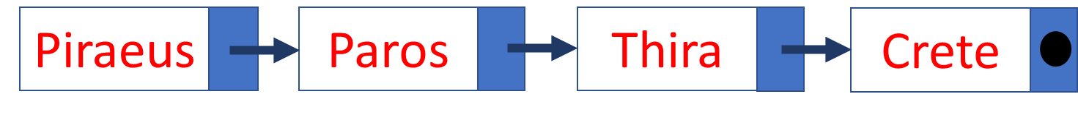

You can also insert items in a table at the end of the list with the AddAll command.
Islands.AddAll(Array as String(“Piraeus”, “Paros”, “Naxos”, “Crete”))
Remember
List items counts from 0. So, a list with 4 elements has the element(0) until element(3)

Insert an item in a specific location
To insert between two elements a third you can use the InsertAt property
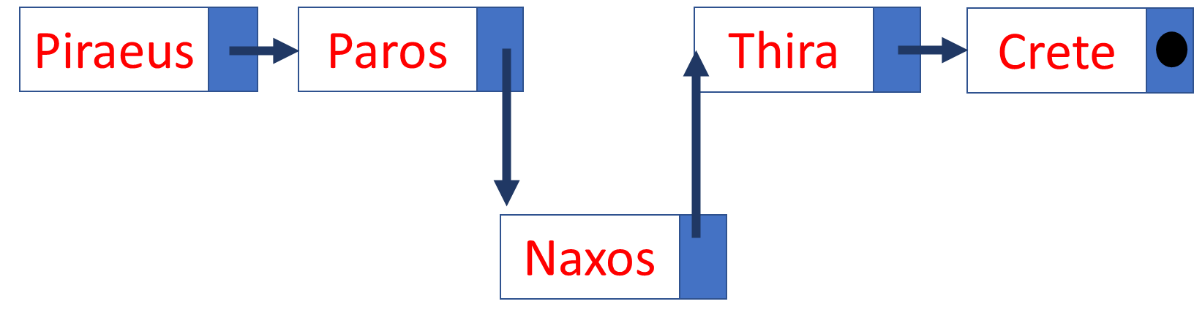

Islands.InsertAt(2, “Naxos”)

In the above example is inserted between Paros and Thira the island of Naxos in 3rd place.

Remove an item from a specific location
The RemoveAt command removes a list item from a specific location.
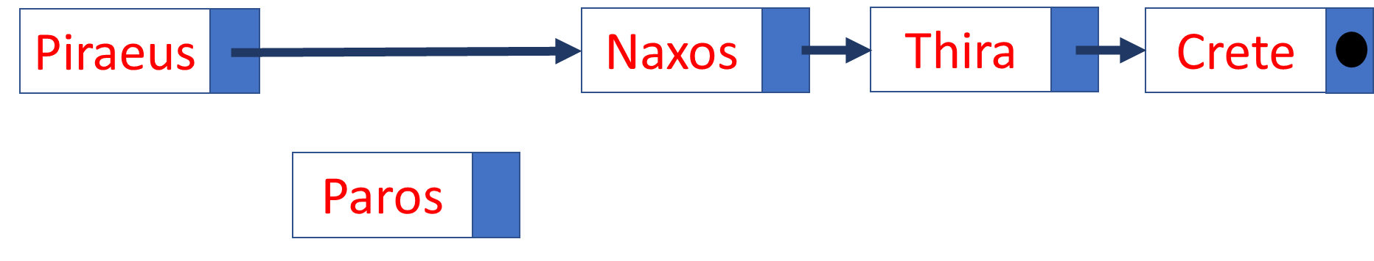
Islands. RemoveAt(1)

In the example above, Paros’s island is removed from the list.

Change position value
With Set command you to change one value of a location with another value that you enter.
Islands.Set(4, “Rhodes”)
Here the value of 5th place changes to "Rhodes".

More commands in lists
- List size.
Islands.Size
In the list of the image returns the value 5.

- Sort a list. You can sort a list in ascending or descending order with sort
Islands.Sort(True) ' Sortby ascending order
Islands.Sort(False) ' Sortin descending order

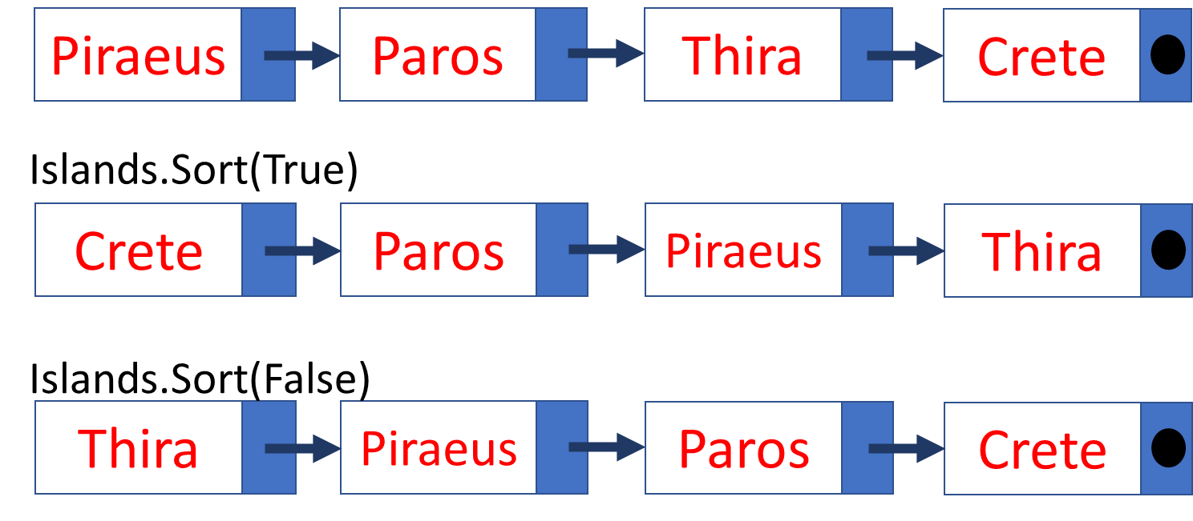
- Empty List
A list empties with the Clear command
Islands.Clear

- Move through a list
Moving within a list with a repetitive command
For i = 0 to Islands.Size – 1 ‘Remember it begins from 0
Log(islands.Get(i))
Next

- You can take advantage of the values in a list by assigning its values to other variables:
For i = 0 to Islands.Size – 1
Private isle As String
Isle = islands.Get(i)
Log(Isle)
Next

- Insert other types of items
A list can store items of any simple or complex type you want. For example, each item in a list could be an object or an entire table.
In the following example, each item in a list is an integer table:
'Create a list of arrays
Private StudentsGrades As List
StudentsGrades.Initialize

For j = 0 To 4
Private Grades(5) As Int
For i = 0 To 4
Grades(i) = Rnd(1, 100) 'Create 5 random Grades For student
Next
StudentsGrades.Add(Grades)
Next

'Show Students Grades
For j = 0 To StudentsGrades.Size - 1
Log("Student: " & j)
Private stGrades(5) As Int = StudentsGrades.Get(j)
For I = 0 To 4
Log(stGrades(i))
Next
Next

1
2
3
4
5

- The list is declared and initialized
- For 5 elements in the list, an equal number of tables are created with random numbers between 1 and 100
- Each table is placed at the end of the list with the Add command
- For all items in the list, a table is filled by the item in the list
- The table we got from each item is displayed.

Exercises

  - Create a list of Country and Capital Names. For example, you can use the following countries.
CUBA | HAVANA
CYPRUS | NICOSIA
CZECHIA | PRAGUE
EGYPT | CAIRO
KENYA | NAIROBI
MEXICO | MEXICO CITY
PERU | LIMA
VIETNAM | HANOI
PORTUGAL | LISBON

Source: https://www.boldtuesday.com/pages/alphabetical-list-of-all-countries-and-capitals-shown-on-list-of-countries-poster

  - Display the names of countries starting with the letter "P"
  - In an appropriate text field, enter name of a country and then search the list if that country exists and display the capital city.
  - Make a button to show a dialog asking for new country and capital and add it to list.

